Student: Steve Patterson 
Contact Phone: 248.783.6493
Contact Home E-mail: hybridcalibratorsrule@gmail.com
Contact Student E-mail: steven.patterson@csuglobal.edu
Course Section: 25FD-CSC500-1 – Principles of Programming
GitHub URL:
Assignment: Module 8: Portfolio Milestone
DATE: 11/30/25

PSEUDOCODE:
Class ItemToPurchase
Attributes:
item_name (string)
item_price (float)
item_quantity (int)
item_description (string)
Constructor(name = "none", price = 0, qty = 0, desc = "none")
item_name = name
item_price = price
item_quantity = qty
item_description = desc
Method print_item_cost()
total = item_price * item_quantity
Output item_name + " " + item_quantity + " @ $" + item_price + " = $" + total
Method print_item_description()
Output item_name + ": " + item_description
End Class

Class ShoppingCart
Attributes:
customer_name (string)
current_date (string)
cart_items (list)
Constructor(name = "none", date = "January 1, 2020")
customer_name = name
current_date = date
cart_items = empty list
Method add_item(item)
Add item to cart_items
Method remove_item(name)
found = false
For each item in cart_items
If item.item_name == name
Remove this item
found = true
Break
If found == false
Output "Item not found in cart. Nothing removed."
Method modify_item(updated_item)
found = false
For each item in cart_items
If item.item_name == updated_item.item_name
If updated_item.item_description != "none"
item.item_description = updated_item.item_description
If updated_item.item_price != 0
item.item_price = updated_item.item_price
If updated_item.item_quantity != 0
item.item_quantity = updated_item.item_quantity
found = true
Break
If found == false
Output "Item not found in cart. Nothing modified."
Method get_num_items_in_cart()
total_qty = 0
For each item in cart_items
total_qty = total_qty + item.item_quantity
Return total_qty
Method get_cost_of_cart()
running_total = 0
For each item in cart_items
running_total = running_total + (item.item_price * item.item_quantity)
Return running_total
Method print_total()
Output customer_name + "'s Shopping Cart - " + current_date
Output "Number of Items: " + get_num_items_in_cart()
If cart_items is empty
Output "SHOPPING CART IS EMPTY"
Else
For each item in cart_items
Call item.print_item_cost()
Output "Total: $" + get_cost_of_cart()
Method print_descriptions()
Output customer_name + "'s Shopping Cart - " + current_date
Output "Item Descriptions"
For each item in cart_items
Call item.print_item_description()
End Class

Function print_menu(cart)
choice = "" // start with empty string
While choice != "q"
Output "MENU"
Output "a - Add item to cart"
Output "r - Remove item from cart"
Output "c - Change item quantity"
Output "i - Output items' descriptions"
Output "o - Output shopping cart"
Output "q - Quit"
Output "Choose an option:"
Input choice
If choice == "a"
Output "ADD ITEM TO CART"
Ask user for item name
Ask user for item description
Ask user for item price
Ask user for item quantity
Create new ItemToPurchase object
cart.add_item(new_item)
Else if choice == "r"
Output "REMOVE ITEM FROM CART"
Ask user for name of item to remove
cart.remove_item(name)
Else if choice == "c"
Output "CHANGE ITEM QUANTITY"
Ask user for item name
Ask user for new quantity
Create temporary ItemToPurchase object
(name and new quantity only)
cart.modify_item(temp_item)
Else if choice == "i"
cart.print_descriptions()
Else if choice == "o"
cart.print_total()
Else if choice == "q"
exit menu loop
Else
invalid input, show menu again
End While
End Function
Main Program
Ask user for customer name
Ask user for today’s date
Output customer name
Output date
Create ShoppingCart object using name and date
Call print_menu(cart)
End Program

SOURCE CODE LISTING:
# Student: Steve Patterson
# Contact Phone: 248.783.6493
# Contact Personal E-mail: hybridcalibratorsrule@gmail.com
# Contact Student E-mail: steven.patterson@csuglobal.edu
# Course Section: 25FD-CSC500-1 – Principles of Programming
# Course Module: Module 8: Portfolio Milestone Final Submission
# this is the class created from step one of module 4 portfolio milestone exact descriptions followed from instructions
class ItemToPurchase:
def __init__(self, item_name="none", item_price=0.0, item_quantity=0, item_description="none"):
self.item_name = item_name
self.item_price = item_price
self.item_quantity = item_quantity
self.item_description = item_description
# prints out the item name wth the quantity and piece cost and the total cose per step one instruction
def print_item_cost(self):
total_cost = self.item_price * self.item_quantity
print(f"{self.item_name} {self.item_quantity} @ ${self.item_price:.2f} = ${total_cost:.2f}")
# prints out the item name with its description
def print_item_description(self):
print(f"{self.item_name}: {self.item_description}")
# this is the shopping cart class created from step 4 in module 6. This is the customers shopping cart
class ShoppingCart:
def __init__(self, customer_name="none", current_date="January 1, 2020"):
self.customer_name = customer_name
self.current_date = current_date
self.cart_items = [] # list of cart items
# method to add an item to purchase by appending the item to the cart items
def add_item(self, item_to_purchase):
self.cart_items.append(item_to_purchase)
# method to remove an item from the cart and if the item is not found remove nothing
def remove_item(self, item_name):
item_found = False
for i, item in enumerate(self.cart_items):
if item.item_name == item_name:
del self.cart_items[i]
item_found = True
break
if not item_found:
print("Item not found in cart. Nothing removed.")
# modifies an item that already exists in the cart matched by item name
def modify_item(self, item_to_purchase):
item_found = False
for cart_item in self.cart_items:
if cart_item.item_name == item_to_purchase.item_name:
item_found = True
# update the description only if changed
if item_to_purchase.item_description != "none":
cart_item.item_description = item_to_purchase.item_description
# update the price only if changed
if item_to_purchase.item_price != 0.0:
cart_item.item_price = item_to_purchase.item_price
# update the quantity only if changed
if item_to_purchase.item_quantity != 0:
cart_item.item_quantity = item_to_purchase.item_quantity
break
if not item_found:
print("Item not found in cart. Nothing modified.")
# returns the quantity of all items in the cart and take no parameters
def get_num_items_in_cart(self):
total_quantity = 0
for item in self.cart_items:
total_quantity += item.item_quantity
return total_quantity
# returns the total cost of all items in the cart and take no parameters
def get_cost_of_cart(self):
total_cost = 0.0
for item in self.cart_items:
total_cost += item.item_price * item.item_quantity
return total_cost
# prints the shopping carts items with the total cost
def print_total(self):
print(f"{self.customer_name}'s shopping cart - {self.current_date}")
print(f"Number of Items: {self.get_num_items_in_cart()}")
if len(self.cart_items) == 0:
print("\nYour shopping cart is empty, feel free to add an item")
else:
for item in self.cart_items:
item.print_item_cost()
total = self.get_cost_of_cart()
print(f"\nTotal: ${total:.2f}")
# prints each item in the shopping cart
def print_descriptions(self):
print(f"{self.customer_name}'s shopping cart - {self.current_date}")
print("Item Descriptions")
if len(self.cart_items) == 0:
print("\nYour shopping cart is empty, feel free to add an item")
else:
for item in self.cart_items:
item.print_item_description()
# print the menu and them processes the user input to update the shopping cart
def print_menu(cart):
option = ""
while option != "q":
print("\nMENU")
print("a - Add item to cart")
print("r - Remove item from cart")
print("c - Change item quantity, description, and price")
print("i - Output items' descriptions")
print("o - Output shopping cart")
print("q - Quit")
option = input("Please choose an option to modify your shopping cart: ").lower()
# Validate input
while option not in ["a", "r", "c", "i", "o", "q"]:
option = input("Choose an option: ").lower()
if option =="q":
print("\n Thank you for shopping and have a great day")
break
if option == "a":
print("\nAdd item to the cart?")
name = input("Enter the item name: ")
description = input("Enter the item description: ")
price = float(input("Enter the item price: "))
quantity = int(input("Enter the item quantity: "))
item = ItemToPurchase(name, price, quantity, description)
cart.add_item(item)
# remove item
elif option == "r":
print("\nRemove item from the cart?")
name = input("Item name to be removed: ")
cart.remove_item(name)
# change quantity of item, description or price
elif option == "c":
print("\nYou requested to change the quantity of an item, price or description?")
name = input("Enter the item name you would like to modify: ")
print("Press Enter to leave the price, quantity, or description unchanged.")
# INPUT the new quantity, price or description.
update_quantity = input("Enter the new quantity: ")
update_price = input("Enter the new price: ")
update_description = input("Enter the new description: ")
# init the values
description = "none"
price = 0.0
quantity = 0
# Only update if user actually typed something, check to see if enter was pressed otherwise update
# strip the white space
if update_description.strip() != "":
description = update_description
if update_price.strip() != "":
price = float(update_price)
if update_quantity.strip() != "":
quantity = int(update_quantity)
# Build a temporary item with the fields we want to change from above inputs
temp_item = ItemToPurchase(
item_name=name,
item_price=price,
item_quantity=quantity,
item_description=description
)
# update the cart!
cart.modify_item(temp_item)
# display the descriptions
elif option == "i":
print("\nOUTPUT ITEMS' DESCRIPTIONS")
cart.print_descriptions()
# display the shopping cart
elif option == "o":
print("\nOUTPUT SHOPPING CART")
cart.print_total()
# main function to input customer name and date then display the shopping cart
def main():
customer_name = input("Enter your name: ")
current_date = input("Enter today's date: ")
print(f"\nCustomer name: {customer_name}")
print(f"Today's date: {current_date}")
cart = ShoppingCart(customer_name, current_date)
print_menu(cart)
# standard Python code entry point
if __name__ == "__main__":
main()

SCREENSHOT OF APPLICATION WORKING:

This is the section for the user to enter their name and date. The customer’s name and date is displayed and then the MENU is displayed. The user has the option to add, remove, change (quantity, description, price), display item’s descriptions, and display shopping cart

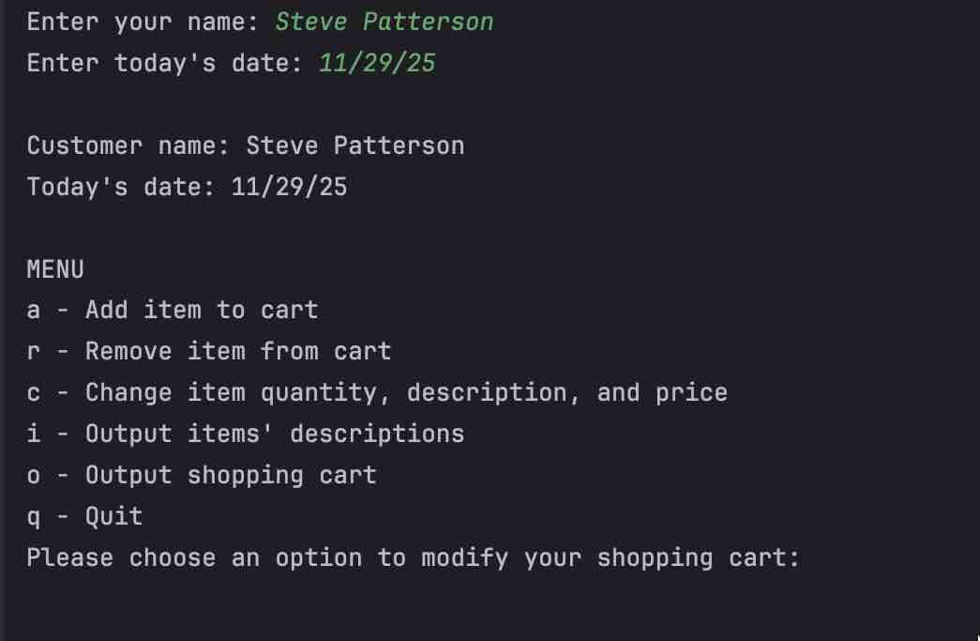

OPTION A: add an item to the cart in this case a shirt, black with a price of $2 and a quantity of 2
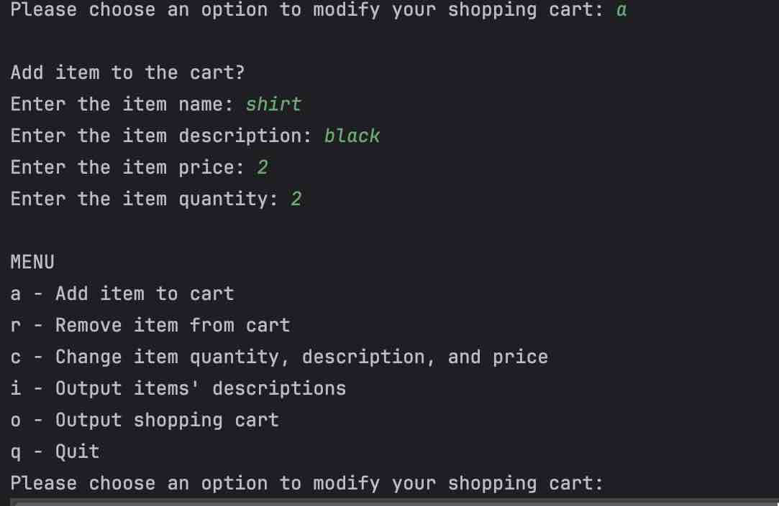

OPTION A: add an item to the cart in this case a pants, blue with a price of $4 and a quantity of 3
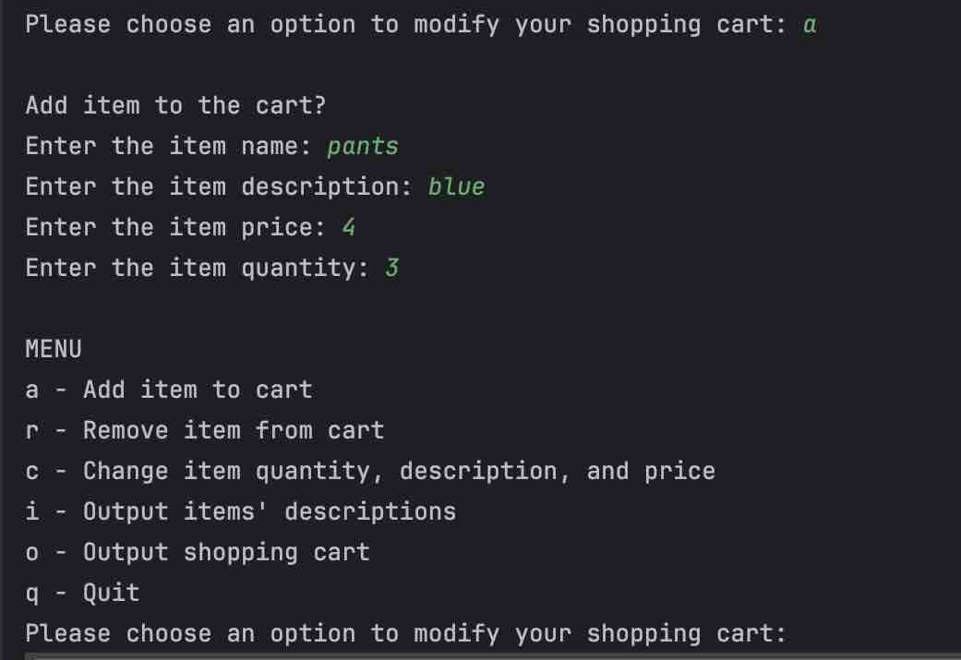

OUTPUT SHOPPING CART: the cart has total of 5 items, with each item being $4 and $12 with a total of $16 in the cart
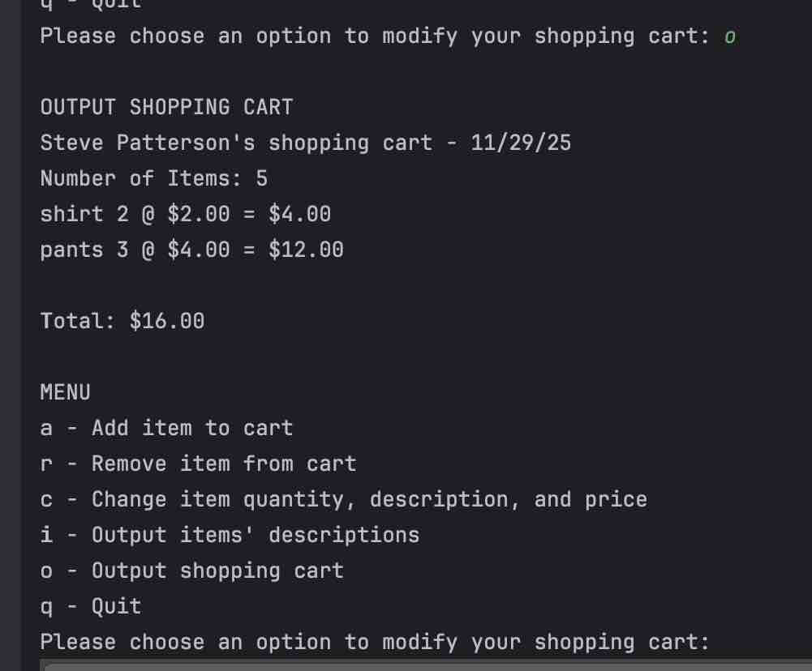

OPTION (i) OUTPUT ITEMS’ DESCRIPTIONS and we have both items listed out with the shirt being black and the pants being blue
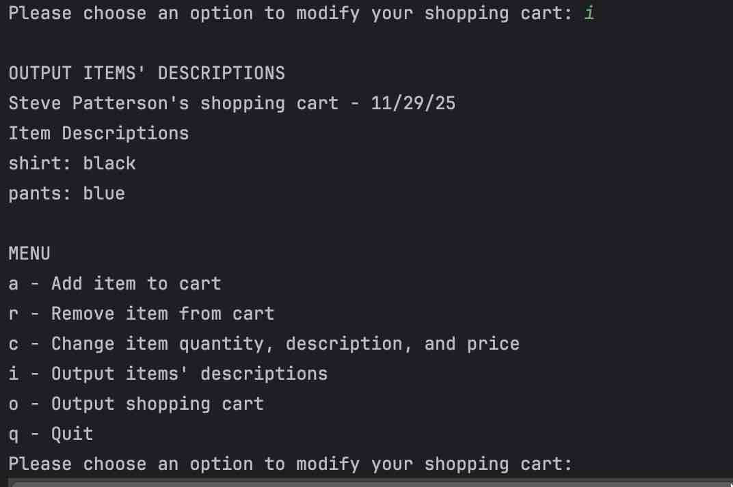

OPTION (‘c’) to modify the quantity of the shirt to 6 and then output the shopping cart showing new quantity and the new total cost of the cart
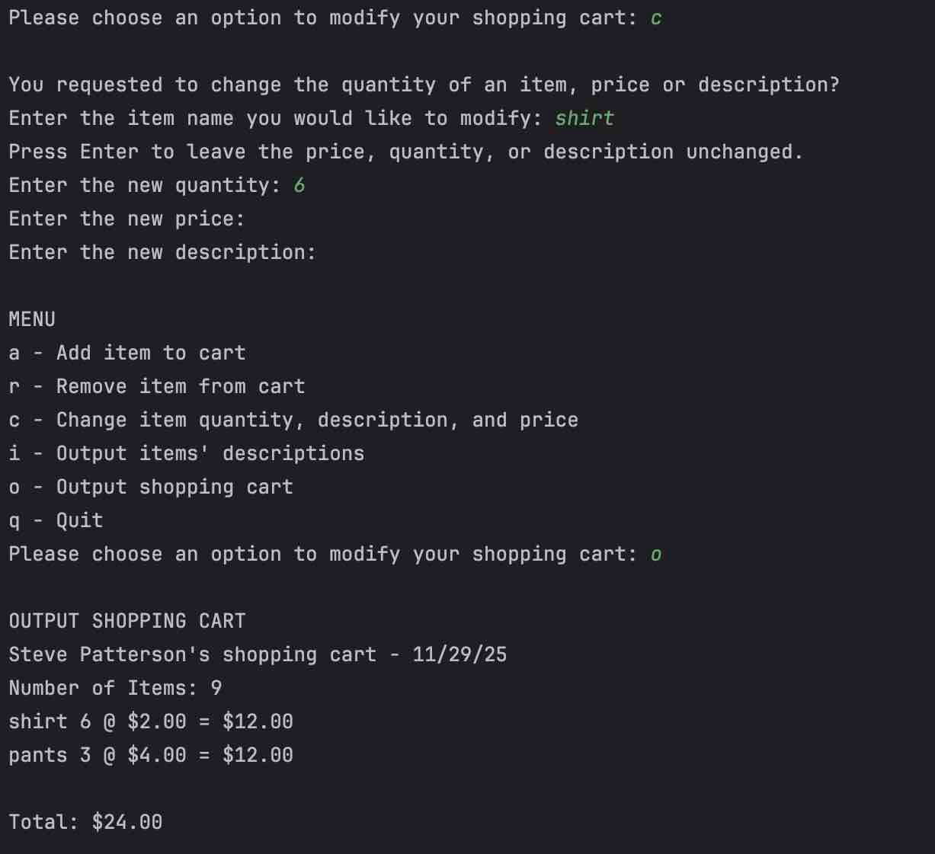

OPTION (‘c’) to change the cost of the pants. The new cost is $9 and the new shopping cart total cost is now $39
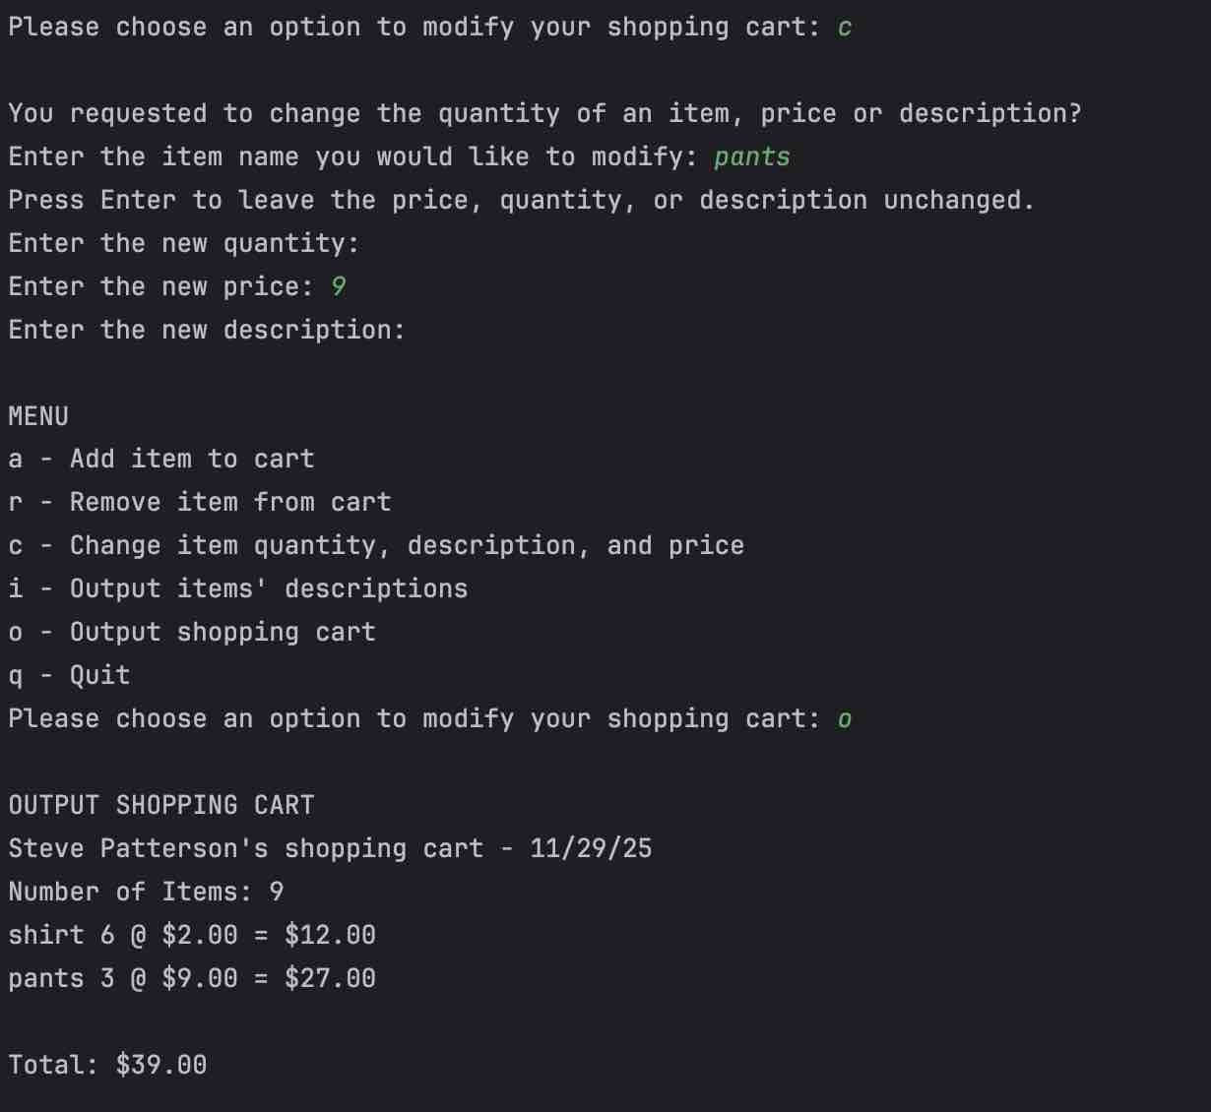

OPTION (‘c’) to change the shirt description to green and labeled it to “change to green” for theatrical effect.
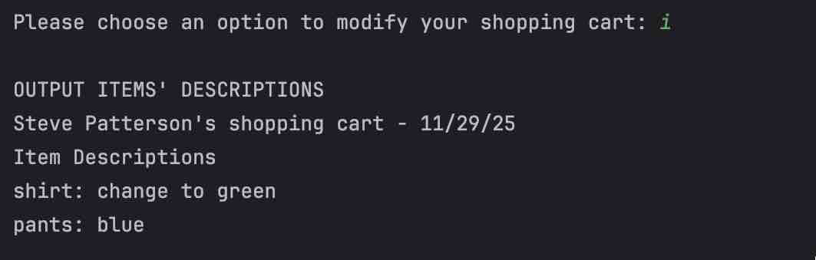

OPTION (‘r’) removes an item from the cart. The item removed was the shirt leaving the pants left in the cart with a total value of $27.

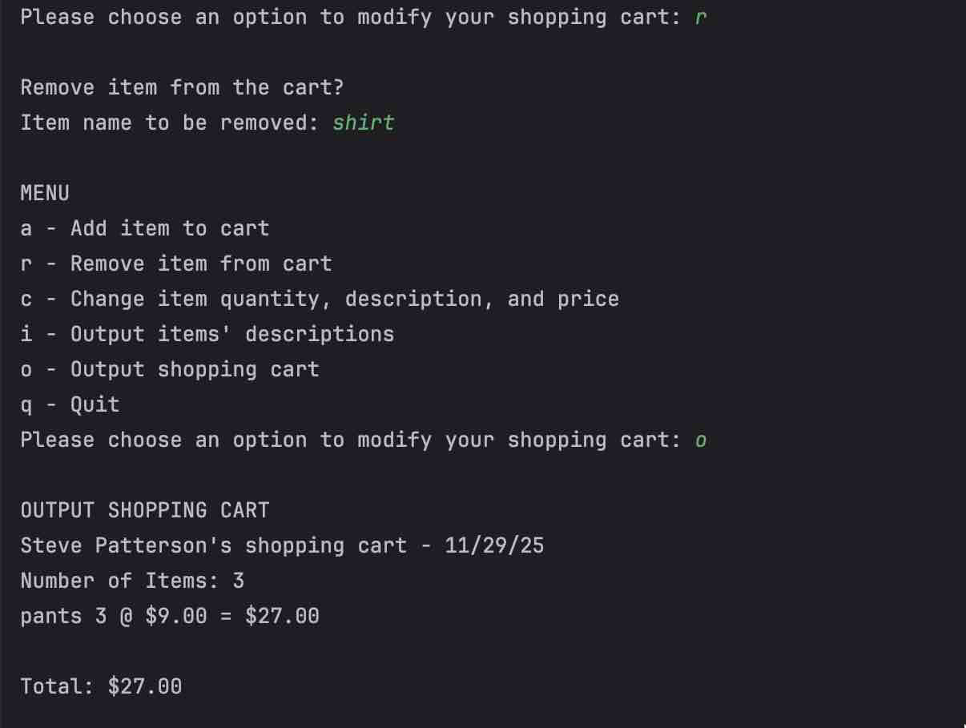

The final option of (q) to end the application leaving the user with “Thank you for shopping and have a great day”
